# Results

This subsection is dedicated to the discussion of the User Testing findings and the subsequent analysis of the extrapolated aggregated data, which are provided in the form of various charts.

## Success rate

The table below illustrates whether each user completed the various tasks successfully. For a clear visualization of the data, each cell contains a **Y** (meaning yes, the user completed it) or an **N** (meaning not completed by the user), and may only be vacant in the case of the first task, since it was designed differently based on the user's profile.



Table 1: Table with Completed/Not Completed tasks per user and Success rate per task

As previously stated, a completed task equates to a score of 1 and a not finished one corresponds to a score of 0, with no values in between.   
The **Success Rate** can be therefore calculated as $SR=\frac{\left(1*CompletedTasks + 0*NotCompletedTasks\right)}{TotalTasks}$; in our case $SR=\frac{\left(1*77 + 0*23\right)}{100}=0,77$ (in percentage **77%**).

Although we cannot state that this is low, we are not completely satisfied with it. As we dive deeper into the results analysis, we will see how this percentage is at this stage for reasons that mostly involve missing widgets, disorganization, misleading pages and minor defects that might be easily corrected. We believe that it can be much raised with a few adjustments on the website.

In any case, from this table it is clear that users had the most difficulty finishing the second and third tasks, but the majority was able to complete the others. Furthermore, there was no clear divide between parents and students, even though we were expecting it.

## Elapsed time

The graph below compares the average time it took users to complete the tasks.

Figure 1: Average elapsed time for completing each task by students and parents

Generally, parents spent slightly more time than students, mainly due to the fact that they had to translate the page using an external web extension, as this feature is not integrated. We imagined that this could have been an obstacle and, in fact, we gave them a less stringent threshold.

Both profiles took more time to complete tasks 2 and 3, because of the poor organisation of the website and the lack of links between correlated pages. Another significant factor is the absence of a research bar.

## Frequency of Homepage usage

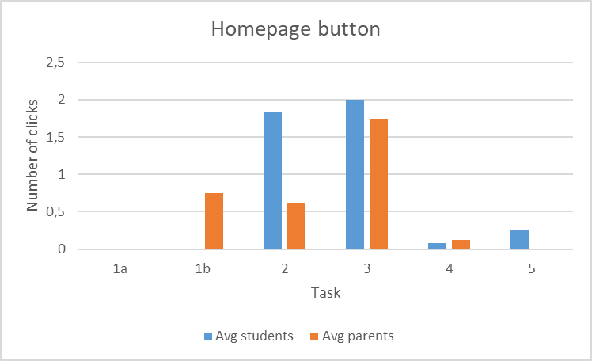Returning to the homepage implies that users faced some difficulties when carrying out the tasks: it happened that after a few failed attempts they had no clue where to find the information so went by chance.

Figure 2: Average number of times that students and parents returned to the homepage for each task

The graph shows that students had no issues completing task 1a, but they struggled with tasks 2 and 3. They also returned to the homepage more frequently than parents for these ones.

Parents had the most difficulties with tasks 3 and 1b, but had no trouble with task 5.

## Frequency of Browser back button usage

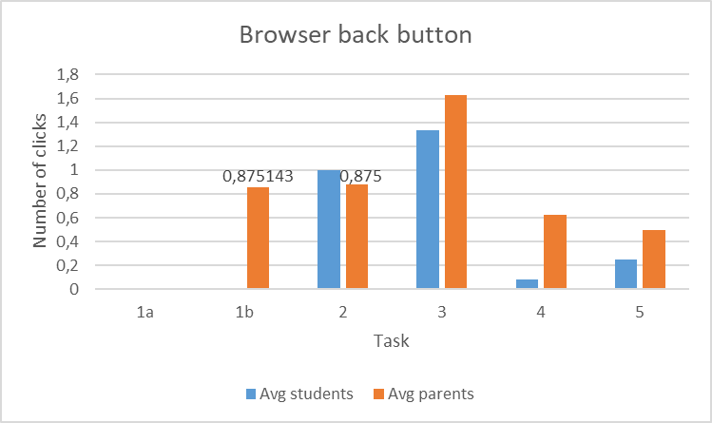Some parts of the website have incorrect bread crumps or no bread crumps at all, leaving users unable to go back by other means than their browser “back button” functionality.

Figure 3: Average number of times that students and parents used the browser back button for each task

An example of this is the *Program Fees* page.

Parents, on average, relied on this function more frequently than students.

This graph confirms that the most challenging tasks were 2 and 3 for students, and 1b and 3 for parents.

## Details for each task

### Task 1a: Application

This task was intended specifically for **students**, since they are the ones who must fill out the form with their personal information, the type of internship they are looking for, as well as their professional sector and cities of interest. The website contains several buttons that lead to the application page, which has a clear structure: each form field has placeholders or lists and, in the event of a mistake, explicitly defines it in simple terms. For these reasons, we were not expecting difficulties.

As a matter of fact, everyone completed this task and perceived it as easy, even though some users thought it might have taken less time if not for certain minor drawbacks.

As an example, when entering their phone number, the user was also required to pick their Country Code from a drop down menu. The Italian one was in the beginning of the list, and not in the position 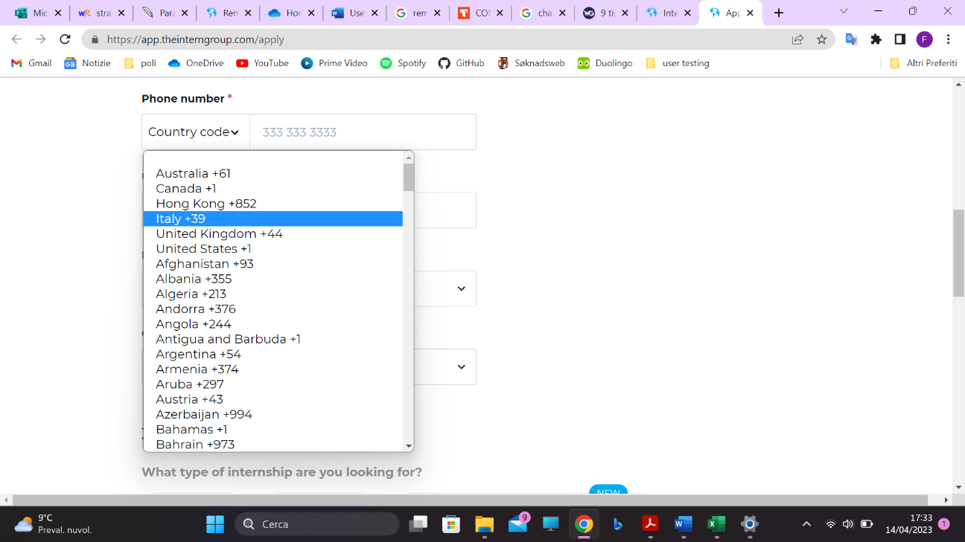it should have been according to the alphabetical order. Some of the users immediately scrolled down, and felt a little bit perplexed and disoriented as they did not find it there.

Others felt they wasted time by not clicking on the “Apply Now” link at the top of the page (missing it due to distraction), but rather accessing a specific section of the website (e.g. Application Process or University/College student), reading a portion or all of it, and then sending the application from a link found there.

Figure 4: Italian Country Code is not placed in alphabetical order

### Task 1b: Parent’s testimonials

This task was designed for **parents** because (especially in the case of high school students) it is reasonable that they would seek out other parents' perspectives and opinions, and highly value them, in order to feel reassured that their daughter or son will actually benefit from the programs offered by this specific organization. The page of the website containing this information is not directly accessible from the upper menu, but it seemed intuitive to reach it via *Who you are > A parent of an applicant*.

This task had a high Success Rate and it was not considered difficult overall.

It is worth noting though that some users wasted a significant amount of time roaming through the Homepage, or focused their attention on other sections of the website that were equally plausible, for example *Blog > Parents and Internship*.

### Task 2: New York cost of life

This was a tricky task, meant to demonstrate that the desired information is in an entirely different section than our intuition would take us to. The correct path to find the average cost of life for a week in New York is *How it works > Eligibility* or *How it works > Financing*, and then going to the *Cost of living* section that appears on the left menu. One would expect this information to be included on the city's page, so our guess was that most users would not manage to find it.

Indeed, it has the lowest Success Rate: most of the people found it very difficult and weren’t able to complete it in the given time.

The ones who succeeded mainly found it by chance, after receiving a little help or because they were really fast in jumping from one page to the other. And still they pointed out how hard it was to find or how oddly it was located.   
They lost so much time into carefully reading everything that was written in the *New York* or *Program Fees* pages, while some also tried to apply for an internship in NY to see if the information would appear there.

### Task 3: What’s NOT included in the fee

This is another tricky task, introduced to prove that also in this case the information is not where it should be. What’s NOT included is in fact written in the *FAQs* section, reachable after going to *How it works > Financing*.

This task had a 50% success rate, and just like the previous one was perceived as difficult. People were nervous during this task because they felt like they were not capable of retrieving the information they were seeking.

Generally, they tried to find it going to the *Program Fees* page, which only referred to what is included. It did not have any link to the FAQs section. Many attempts were taken trying to figure what was missing in the “included things” list, giving answers that was reasonable but incorrect, coming from personal experience (e.g. “the flight is not included”) but not found on the website.

Some doubts on the meaning of the task itself were also raised (e.g. “which program are we talking about?”).

### Task 4: Employees’ profiles

This task required users to navigate to the *Who we are > Our team* page, filter for Latin American employees and find one of them with a LinkedIn profile to open.

Everyone succeeded but not without issues.

The dropdown menu that allows you to filter for nationality overlaps with the first picture of the page as it opens below (as it was also mentioned in the Inspection part of this report). Many users encountered this problem and felt disoriented. Some tried to fix it and casually managed to, others were led to thinking that they had to manually check each profile, or even that it was not the proper page and left, only to return later.

Some users almost did not notice the menu at first because it is not accompanied by words, and they were moving too quickly towards the images. It has a tiny placeholder that merely says “Any”, so does not provide relevant information but one has to presume that's what they have to click.

### Task 5: Accommodation photos

This is another task for which users had to reach a page not immediately accessible from the upper menu. In this case, the path to follow was *Destinations > By Season > Summer Internships 2023*, and then find the pictures of the accommodations in the dedicated section.

95% of the users completed this task and did not perceive it as difficult.

However, many users spent a lot of time in other areas of the website since they had not noticed the *By Season* option under *Destinations*, that allows to actually filter for season.  
Some users therefore initially tried to guess hypothetical cities where it would be possible to go in Spring, or tried to select a specific date in the calendar of the *Program Fees & Start Dates* page, a thing that the website does not allow.

## People’s feedback

After the test, users were asked to respond to eight questions on their happiness, general perceptions of the site's content, ease of use, and exploration. Each question received a score ranging from 1 (strongly disagree) to 5 (strongly agree).

We can back up what we already know from the data by analyzing the findings of this **post-test questionnaire**: content organization and navigation struggles are a major issue that detracts from the overall user experience.

Everyone understood the tasks’ requirements quite well, and the visuals of the website were appreciated. They complained though about the fact that not every section of the website was easily accessible, which created annoyance and upsetting, and therefore received the lowest grade.

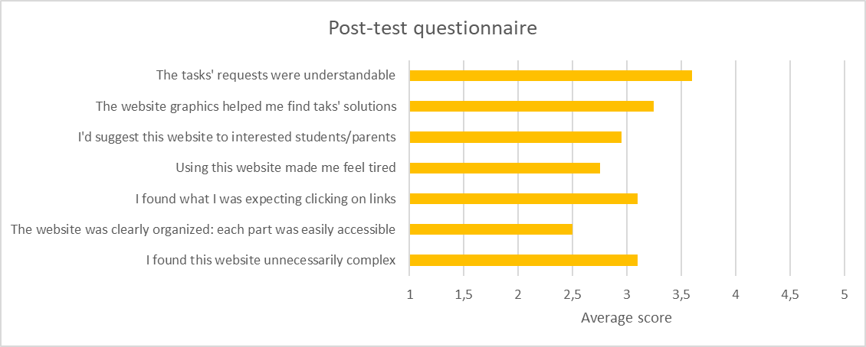

Figure 5: Average scores given by users in the post-test questionnaire

Even though the topic is relevant and intriguing, and involved persons must see the website in any case if they are interested in doing internships offered by this organization, users did not appear to be convinced in recommending it to others.

Finally, they were asked for more remarks, both favourable and negative. They mostly focused and dwelled on the negative ones, and the highlighted aspects are the following:

* 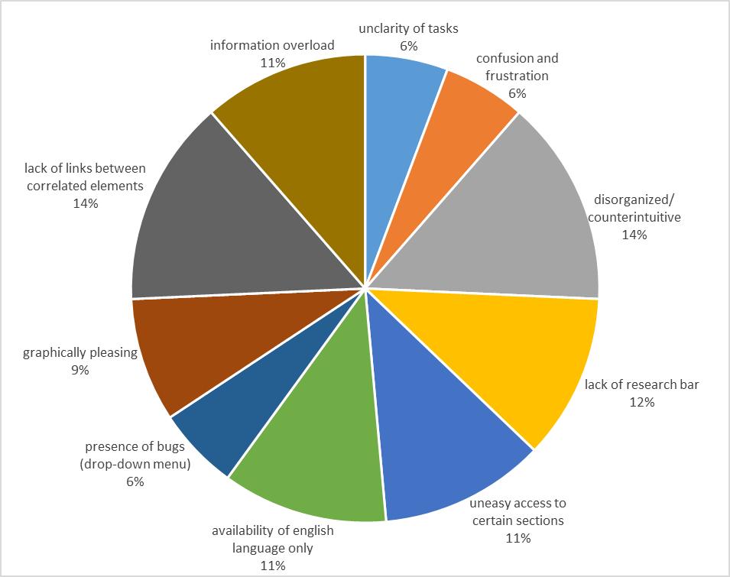some parts of the website are **difficult to find** (e.g. *Cost of living* page, fees related *FAQs* …), due to **disorganization** and to the **lack of useful links** that connect related topics;

Figure 6: People’s general comments on the website

* the website **lacks of a research bar**;
* there are pages that contain the same material as others, making the website redundant, sometimes confusing, and resulting in **information overload**;
* there is no possibility of **changing the language** of the website natively.